## SECTION 4

### ENTITY RELATIONSHIP DIAGRAM



An entity relationship model, also called an entity-relationship (ER) diagram, is a graphical representation of entities and their relationships to each other, typically used in computing in regard to the organization of data within databases or information systems.

The Entity Relationship Diagram of my system is given below:

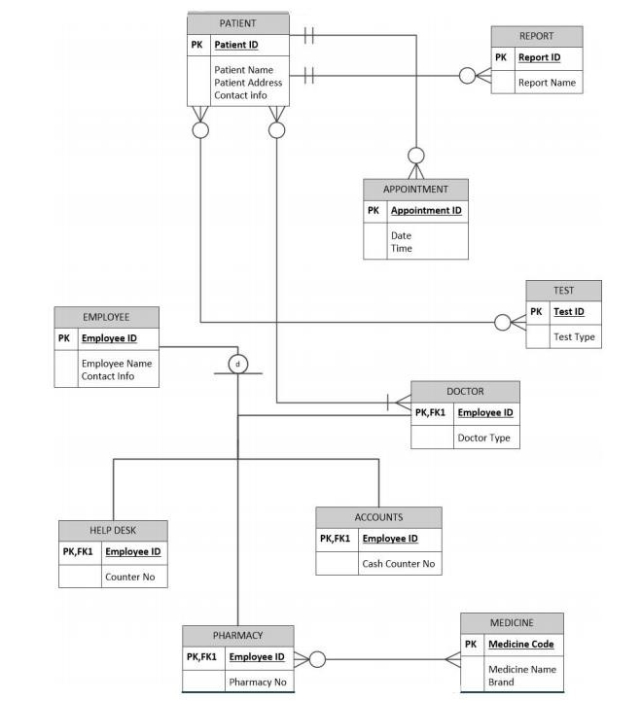

### LOGICAL DATA FLOW DIAGRAM



A logical DFD captures the data flows that are necessary for a system to operate. It describes the processes that are undertaken, the data required and produced by each process, and the stores needed to hold the data.

The Logical Data Flow diagram of my system is given below:

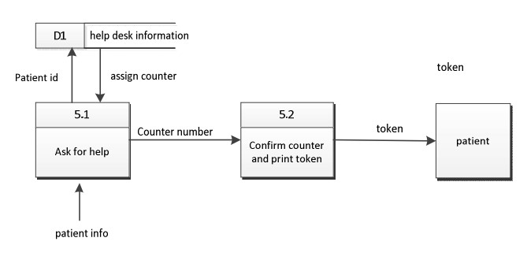

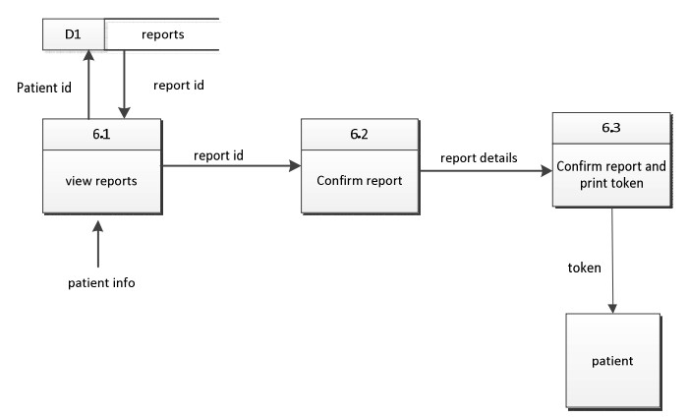

### PHYSICAL DATA FLOW DIAGRAM



A logical DFD focuses on the business and business activities, while a physical DFD looks at how a system is implemented. So while any data flow diagram maps out the flow of information for a process or system, the logical diagram provides the “what” and the physical provides the “how.”

The Physical Data Flow diagram of my system is given below:

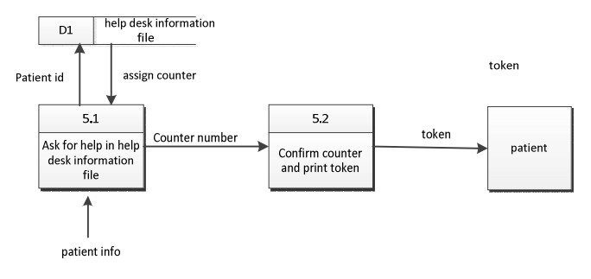

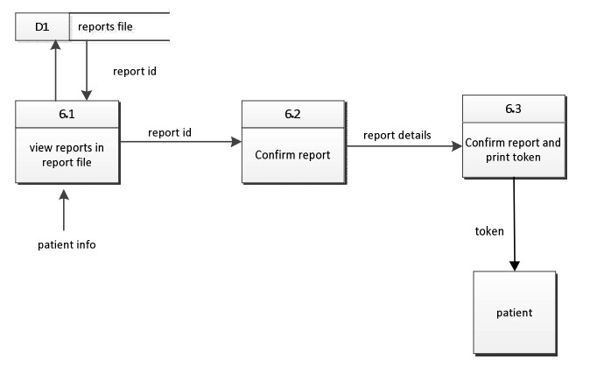

### ACTIVITY DIAGRAMS FROM USE CASE DIAGRAMS



Activity diagram is another important diagram in UML to describe the dynamic aspects of the system. Activity diagram is basically a flowchart to represent the flow from one activity to another activity. The activity can be described as an operation of the system. The control flow is drawn from one operation to another.

The Activity Diagrams of my system is given below:

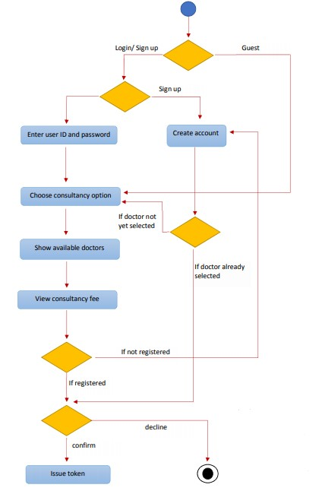

Figure: The figure depicts how a patient can get an appointment with the doctor through the system.

### SEQUENCE AND COMMUNICATION DIAGRAMS



#### SEQUENCE DIAGRAM

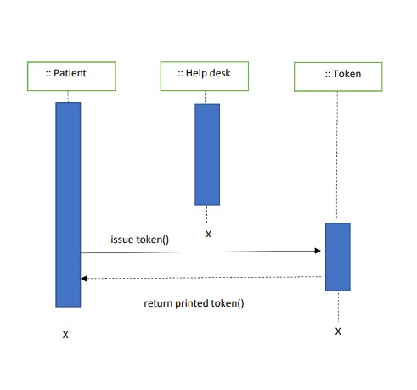

Figure: showing how a patient can get help from help desk.

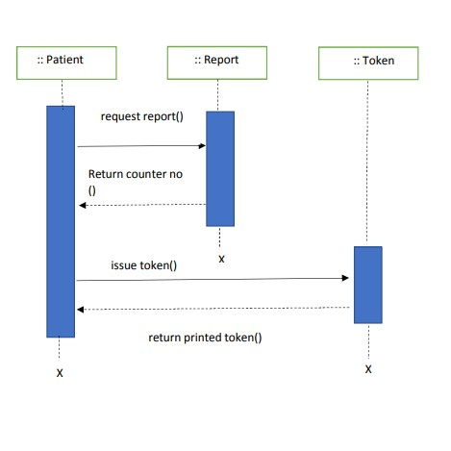

Figure: showing how a patient can get report from report counter.

#### COMMUNICATION DIAGRAM

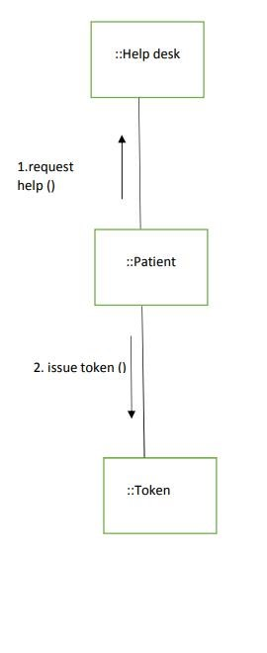

Figure: showing how a patient can get report from report counter using the system.

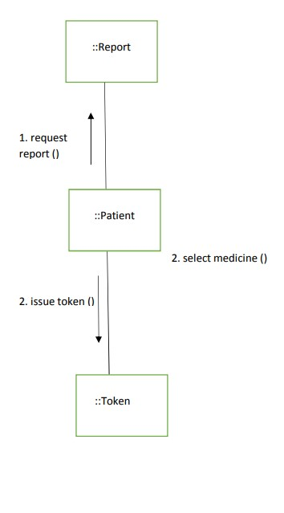

Figure: showing how a patient can get report from report counter using the system.

### CLASS DIAGRAMS

A class diagram in the Unified Modeling Language (UML) is a type of static structure diagram that describes the structure of a system by showing the system's classes, their attributes, operations (or methods), and the relationships among objects.

The Class Diagram of my system is given below:

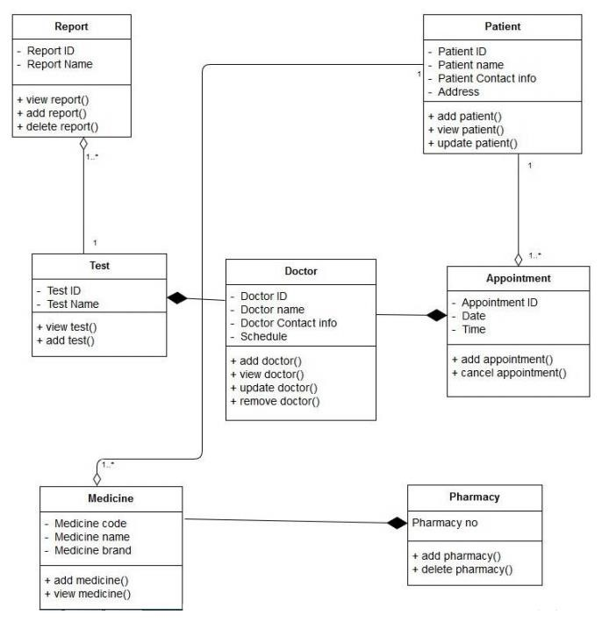

### STATE CHART DIAGRAMS



A state diagram, also called a [state machine](https://whatis.techtarget.com/definition/state-machine) diagram or state chart diagram, is an illustration of the states an object can attain as well as the transitions between those states in the Unified Modeling Language (UML).

The state chart diagrams of my system is given below:

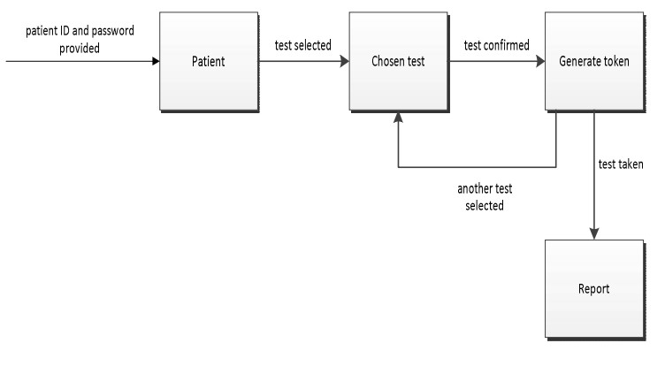

Figure: This state chart diagram shows how a patient can get a token for getting report.

### CRUD MATRIX



|  |  |  |  |  |  |  |  |  |
| --- | --- | --- | --- | --- | --- | --- | --- | --- |
| **Activity** | **Patient** | **Doctor** | **Appointment** | **Bill** | **Medicine** | **Test** | **Report** | **Token** |
| **Patient Logon** | R |  |  |  |  |  |  |  |
| **Doctor Inquiry** |  | R |  |  |  |  |  |  |
| **Get Appointment** |  |  | C |  |  |  |  | C |
| **Cancel Appointment** |  |  | D |  |  |  |  |  |
| **Search medicine** |  |  |  |  | R |  |  |  |
| **Buy Medicine** |  |  |  | C |  |  |  | C |
| **Search Test** |  |  |  |  |  | R |  |  |
| **View Report** |  |  |  |  |  |  | R | C |
| **Add Report** |  |  |  |  |  |  | C |  |
| **Delete Report** |  |  |  |  |  |  | D |  |
| **Change Doctor Information** |  | RU |  |  |  |  |  |  |
| **Add doctor** |  | C |  |  |  |  |  |  |
| **Add patient** | C |  |  |  |  |  |  |  |
| **Change Patient Information** | RU |  |  |  |  |  |  |  |